**Ampere’s Law**

**Magnetic Field due to a Current Carrying Wirte**

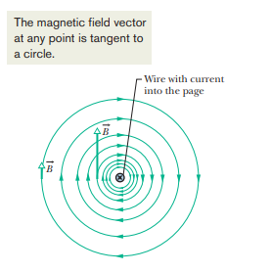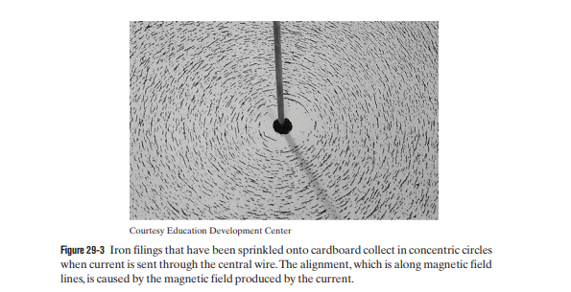 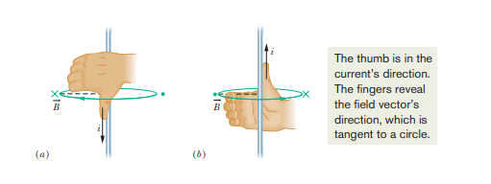

1. **A surveyor is using a magnetic compass 6.1 m below a power line in which there is a steady current of 100 A. (a) What is the magnetic field at the site of the compass due to the power line? (b) Will this field interfere seriously with the compass reading? The horizontal component of Earth’s magnetic field at the site is 20 mT.**

**Magnetic Field Due to a Current in a Circular Arc of Wire**

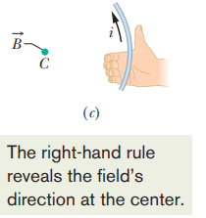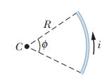



**To find the magnitude of the magnetic field at the center of a full circle of current, you would substitute 2π rad for Φ.**

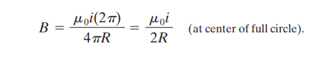

1. **In Fig. a wire forms a semicircle of radius R = 9.26 cm and two (radial) straight segments each of length L = 13.1 cm. The wire carries current i = 34.8 mA. What are the (a) magnitude and (b) direction (into or out of the page) of the net magnetic field at the semicircle’s center of curvature C?**

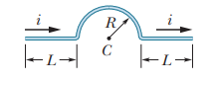

**Force Between Two Parallel Currents**

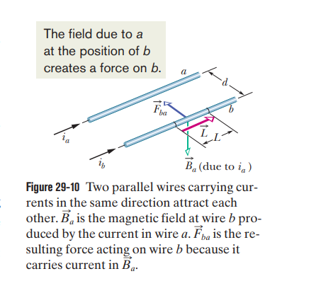

**Force on a length L of wire b due to the external magnetic field is**



Similarly, *Fab = ia L x Bb*

**Important**

**So, the two conducting wires will attract each other and if we reverse the direction of the current they will repel each other.**

**Magnetic Field inside a Solenoid**

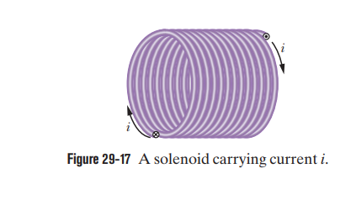 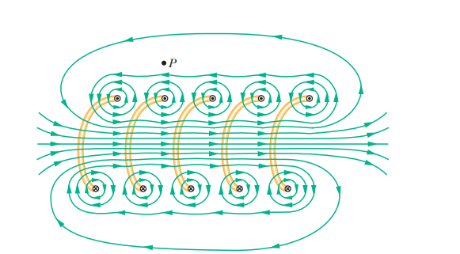



**Magnetic Field inside a Toroid** 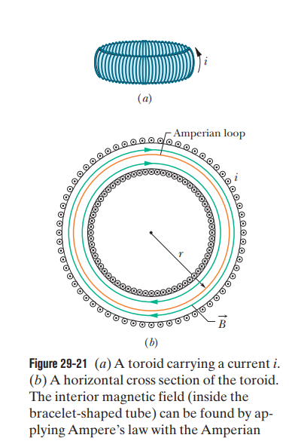

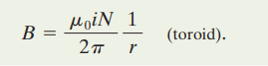

1. A solenoid that is 95.0 cm long has a radius of 2.00 cm and a winding of 1200 turns; it carries a current of 3.60 A. Calculate the magnitude of the magnetic field inside the solenoid. •

